NAME: R DINESH
REG NO: 192421117

PERPLEXITY AI CASE STUDY

ABOUT PERPLEXITY CASE STUDY
Perplexity AI, founded in 2022, is an AI-powered answer engine that delivers real-time, accurate, and citation-backed responses to user queries. Unlike traditional search engines, Perplexity provides direct answers instead of links, improving user efficiency.
The platform integrates Large Language Models (LLMs), real-time web crawling, retrieval-augmented generation (RAG), and citation engines to ensure transparency and trust.
Perplexity faced challenges such as real-time data retrieval, hallucination control, scalability of AI inference, and user data security.
To solve this, Perplexity built a unified AI Search Architecture that seamlessly integrates query processing, retrieval systems, LLMs, and citation validation.
- Founded: 2022
- Global Users: Millions worldwide
- Daily Queries: Millions
- Platforms: Web, Mobile
- Core Strength: Citation-backed AI answers
Challenges
- Real-time data fetching from the web
- Preventing hallucinations in AI answers
- Scaling LLM inference efficiently
- Maintaining data security and privacy
- Ensuring answer transparency
Core system used
Perplexity AI operates using a set of tightly integrated core systems that work together to deliver fast, accurate, and citation-backed answers. These systems ensure efficient query handling, reliable information retrieval, intelligent response generation, and scalable performance.
- • Query Management System (QMS) – Manages and processes all incoming user queries in a structured manner.
• Retrieval Engine (Search + Index) – Fetches relevant information from live web sources and indexed datasets.
• Large Language Model (LLM) Engine – Generates human-like, context-aware answers using advanced AI models.
• Citation & Source Validation Engine – Ensures answers are backed by credible and verifiable sources.
• Cloud Infrastructure – Provides scalable computing, storage, and high availability for AI services.

Query Management System (QMS)
Handles all user queries in a centralized manner. It cleans and understands queries, detects user intent, balances load across AI services, and tracks queries in real time to ensure smooth and efficient processing.
- Centralized query handling
- Query normalization and intent detection
- Load balancing across AI services
- Real-time tracking of user queries

Retrieval Engine (Search + Index)
Fetches relevant information from live web sources and indexed datasets. It ranks results based on relevance and context, ensuring that only accurate and up-to-date information is passed to the AI model.
- Live web search integration
- Indexed trusted data sources
- Contextual document retrieval
- Ranking and relevance scoring

Large Language Model (LLM) Engine
Processes retrieved information to generate clear, context-aware, and human-like answers. It supports follow-up questions and minimizes incorrect or hallucinated responses.
- Context-aware answer generation
- Hallucination reduction techniques
- Multi-turn conversational memory
- Answer summarization

Citation & Source Validation Engine
Automatically links answers to trusted sources. It validates references and ensures transparency by displaying citations along with generated responses.
- Automatic source attribution
- Citation validation
- Linking answers to trusted sources
- Transparent answer generation

Cloud Infrastructure
- Provides scalable computing power, storage, and high availability. It supports real-time AI processing, handles high query volumes, and ensures system reliability and security.

2.Objectives of the Perplexity AI App
- To provide instant, accurate, and AI-generated answers to user queries.
- To reduce the time and effort required to search information on the web.
- To deliver citation-backed responses that improve trust and transparency.
- To support conversational and follow-up queries for better understanding.
- To minimize misinformation by validating answers with reliable sources.
- To ensure secure handling of user data and privacy protection.
- To offer a scalable and high-performance AI-powered search platform.

3.Stakeholders
Stakeholder | Role
Users | Ask questions and receive AI-generated answers
AI Engineers | Develop, train, and maintain AI models
Data Providers | Supply web data and information sources
Cloud Service Providers | Provide computing, storage, and scalability
Admin | Monitor platform performance and usage
Security Team | Ensure data privacy and system security

4. Functional Features

4.1 User Features

• User registration & login
• Text-based question input
• AI-powered search and answers
• Follow-up questions (conversational search)
• Citation-based answer display
4.2 Admin Features

• User and query monitoring
• AI model performance management
• Source and citation management
• Usage analytics and reporting
• Security and access control

5. System Architecture Overview

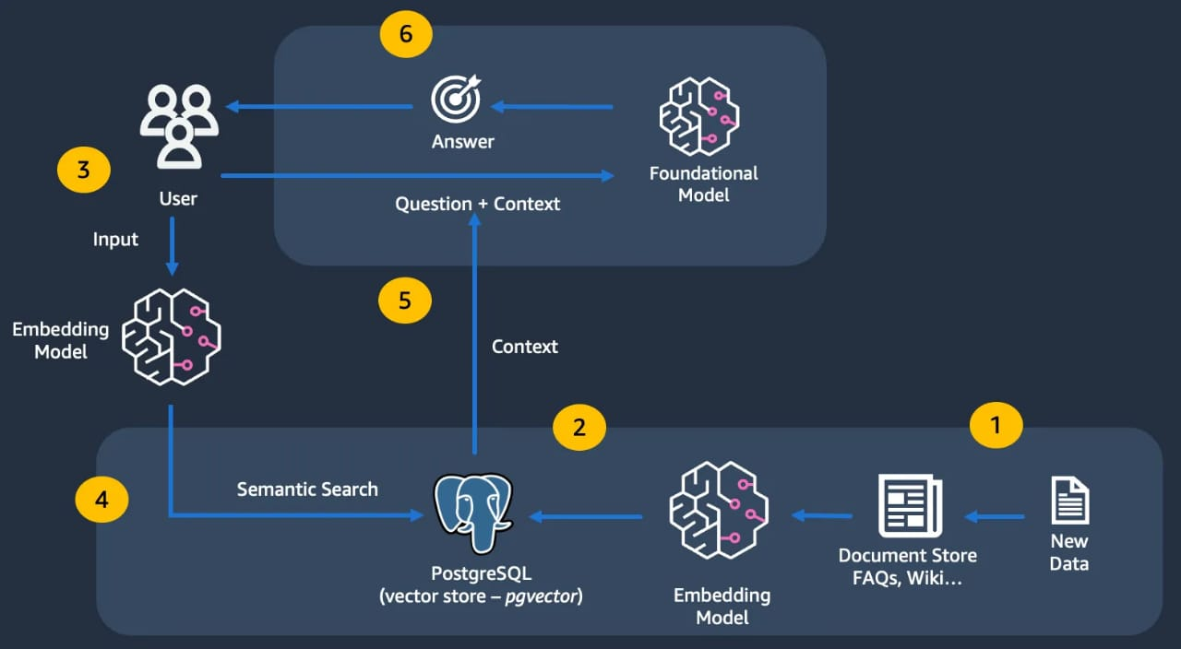

Architecture Type

• Client–Server Architecture
• AI-driven Microservices-based backend
• Cloud-hosted infrastructure

Main Components

• Web Application (Browser-based UI)
• Mobile App (Android / iOS)
• Backend APIs
• AI Processing Engine (LLM Services)
• Retrieval & Citation Engine
• Database Servers
• Cloud Infrastructure

6. Database Design Summary

Key entities used in the Perplexity AI database:

• User
• Query
• Response
• Source

• Citation
• Feedback
• Usage Logs

➡️ The database follows a hybrid design using relational and NoSQL databases to ensure scalability, fast query handling, and reduced data redundancy.

7. Technology Stack Used
Layer | Technology
Frontend | Web (HTML, CSS, JavaScript), Mobile (Android / iOS)
Backend | Python, FastAPI
AI Models | Large Language Models (LLMs)
Database | PostgreSQL, MongoDB
Cloud | AWS
Analytics | Power BI
Security | OAuth 2.0, JWT

8. Security Features

• HTTPS / SSL encryption
• Secure user authentication
• API rate limiting
• Encrypted data storage
• Role-based access control
• Secure AI and backend APIs

9. Supply Chain & Logistics Model
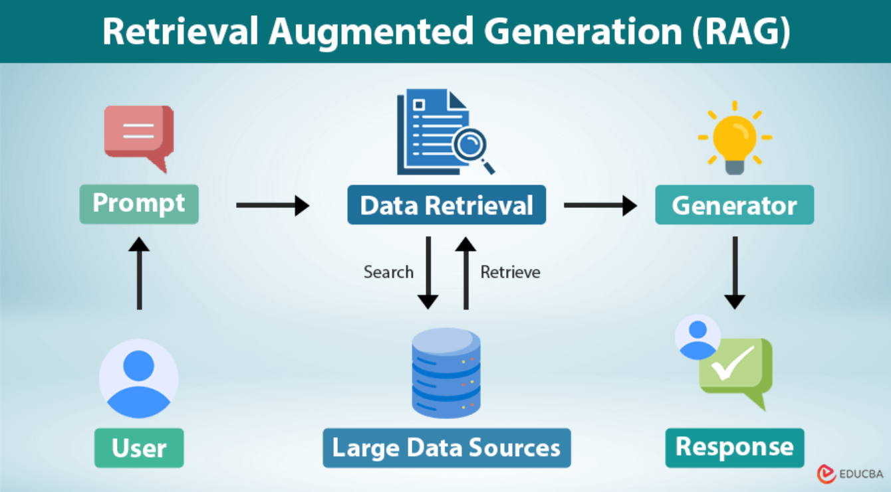
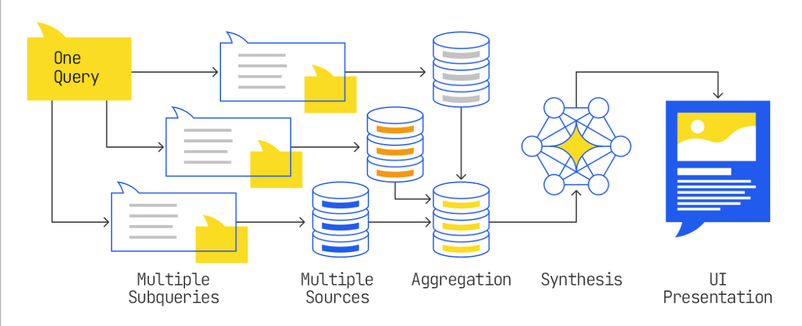

Flow:
User Query
→ Query Management System
→ Retrieval Engine (Web Search + Index)
→ Large Language Model (LLM)
→ Citation & Source Validation
→ AI-Generated Answer
→ User

Perplexity( App – Database Design Structure (ER Diagram View)
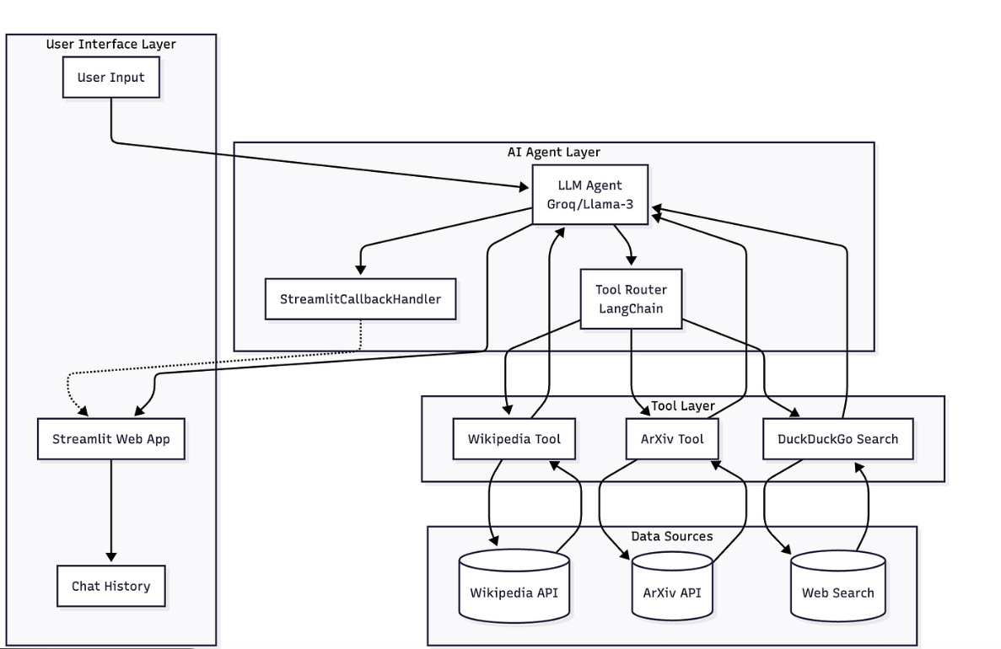

Perplexity AI App – Database Design Structure

1. User
• user_id (PK)
• name
• email
• password
• role (user/admin)
• created_at
➡️ One user can submit many queries

2. Query
• query_id (PK)
• user_id (FK)
• query_text
• query_time
• query_status
➡️ One user can have multiple queries

3. Response
• response_id (PK)
• query_id (FK)
• response_text
• generated_time
• confidence_score
➡️ One query generates one response

4. Source
• source_id (PK)
• source_name
• source_url
• source_type (web/article/research)
➡️ One source can be used in many responses

5. Citation
• citation_id (PK)
• response_id (FK)
• source_id (FK)
• citation_text
➡️ One response can have multiple citations

6. Feedback
• feedback_id (PK)
• response_id (FK)
• user_id (FK)
• rating
• comments
➡️ Users can give feedback for responses

7. Session
• session_id (PK)
• user_id (FK)
• session_start
• session_end
➡️ One user can have multiple sessions

8. Usage_Log
• log_id (PK)
• user_id (FK)
• query_id (FK)
• timestamp
• action_type
➡️ Used for analytics and monitoring

Relationship Summary (Easy to Remember)
• User → Query : 1 : N
• Query → Response : 1 : 1
• Response → Citation : 1 : N
• Source → Citation : 1 : N
• User → Feedback : 1 : N
• User → Session : 1 : N

1. Frontend (Web & Mobile)
Purpose | Tools / Technologies
Web Application | HTML, CSS, JavaScript
Mobile App | Android, iOS
UI Frameworks | React
Design | Minimal AI-focused UI

2. Backend / Server Side
Purpose | Tools / Technologies
Backend Framework | Python, FastAPI
API Development | RESTful APIs
Microservices | AI-based microservices
Authentication | OAuth 2.0, JWT
Business Logic | Python-based services

3. Database & Data Storage
Purpose | Tools / Technologies
Relational Database | PostgreSQL
NoSQL Database | MongoDB
Caching | Redis
Search Engine | Elasticsearch

4. Cloud & Hosting
Purpose | Tools / Technologies
Cloud Platform | Amazon Web Services (AWS)
Storage | Amazon S3
Compute | EC2
Load Balancer | AWS ELB
Auto Scaling | AWS Auto Scaling

5. AI & Model Management Tools
Purpose | Tools / Technologies
Language Models | Large Language Models (LLMs)
Retrieval System | Search + Indexing Engine
Model Inference | GPU-based AI services
Model Optimization | Prompt tuning
Citation Validation | Source verification engine

6. Analytics & Monitoring
Purpose | Tools / Technologies
Usage Analytics | Google Analytics
Query Analysis | Custom dashboards
Performance Monitoring | AWS CloudWatch
Error Tracking | ELK Stack

7. DevOps & Deployment
Purpose | Tools / Technologies
Version Control | Git
CI/CD | Jenkins
Containerization | Docker
Deployment | Cloud-based pipelines

8. Security Tools
Purpose | Tools / Technologies
Secure Communication | HTTPS / SSL
Authentication | OAuth 2.0, JWT
Data Encryption | AES, TLS
Access Control | Role-Based Access Control
API Security | Rate limiting

